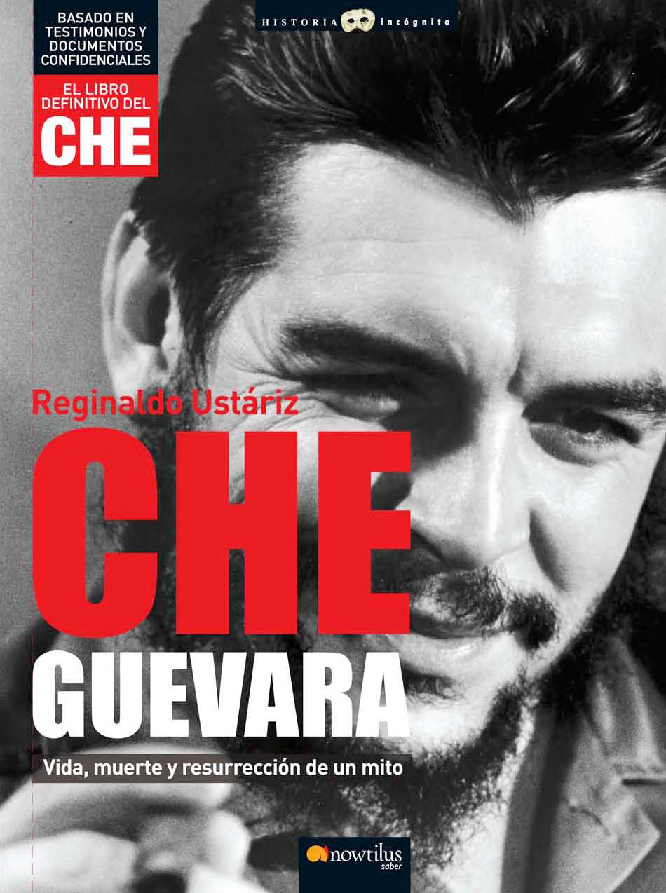
CHE GUEVARA
Life, death and resurrection of a myth

Reginaldo Ustariz Arce
Historical Essay / Popular History
17 x 24 cm
Binding: Hardcover without dust jacket
Richly illustrated in black and white
416 p
ISBN13: 978-849763497-7
SRP: 19,95 €.
Collection: Historia Incógnita/ Unknown History, www.historiaincognita.com
Publishing Date: November 2007

Includes a preface written by Frei Betto

An unprecedented research about Che’s life and death with unpublished details collected by the author during his participation in war and his experience as a witness of Che’s death. The statements of the revolutionary leader’s friends and comrades as well as the unknown Bolivian Army’s confidential documents also add fascinating details to this work. This is the first book to narrate, through photographs, the development of one of the greatest myths of the 20th Century, depicting how Ernesto Guevara de la Serna becomes “Che”.

A unique account that defies fiction to show you the revolutionary leader’s life and the birth of a myth of great significance. It goes from his childhood in Argentina, through his asthma, his trips around America until he reaches Cuba, his friendship with Raúl and Fidel Castro, the battles in the Sierra Maestra, to the guerrilla in Bolivia, his subsequent murder and the author’s formal complaint about this crime, which led him to a long exile…
This is the only book about Che Guevara written in first person by an eyewitness of the events. It is the result of arduous research work, which took him more than four decades, and contains unpublished photographs as well as more than 50 statements of Che’s comrades who joined him in the struggle, friends from childhood, Bolivian military officers and soldiers.

The final book about CHE, based on statements and confidential documents

Reginaldo de Ustáriz is a doctor and a journalist who participated in the war, not directly by fighting, but by providing other services. In 1967, he worked as War Correspondent for the newspaper from Cochabamba, Prensa Libre (Free Press) and, at the same time, was the doctor in a small town near the war zone. He witnessed Che’s death and reported the crime. As a result, he had to go into exile to Brazil, where he currently works as a doctor. He carried out an exceptional investigation for over 40 years, through which he managed to collect over 50 statements of Che’s friends and mates at the times of the guerrilla, and more than 80 photographs that depict the life, death and birth of a myth.

