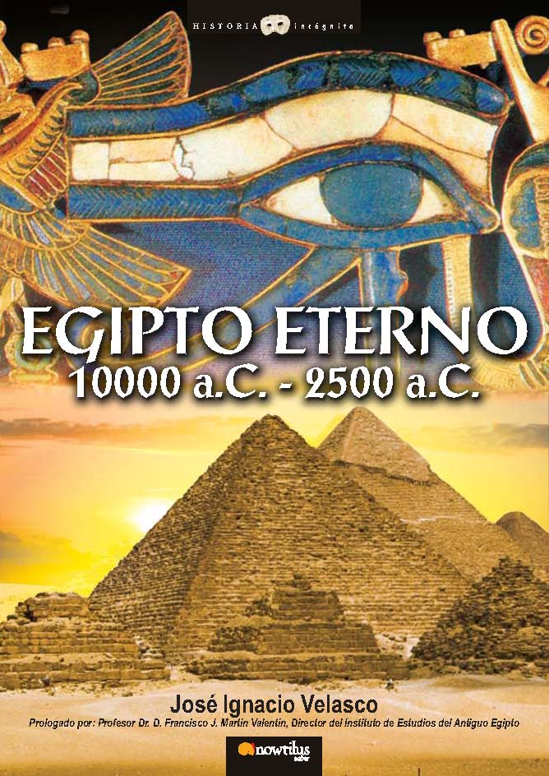
ETERNAL EGYPT, 10000 -2500 B.C.

A journey into the origins of the most captivating civilization in History, going from time immemorial and the legendary age of the God-Kings to the Old Kingdom, period when Egypt was ruled by the mythical pharaohs.
José Ignacio Velasco
Historical Essay / Popular History
19.5x26.5 cm
Binding: Hardcover with dust jacket
Richly illustrated in color
256 p
ISBN13: 978-849763496-0
SRP: 25.95 €
Collection: Historia Incógnita/ Unknown History, www.historiaincognita.com
Publishing Date: November 2007

This is a visual journey into the Egyptian culture during the period that goes from 10000 B.C. to 2000 B.C. You will travel from time immemorial, going through the age of the so-called God-Kings ―a legendary, bygone period lost in the mists of time when Egypt was ruled by the kings Iry-Hor, Scorpion, Narmer and Ka― to the Old Kingdom of the mythical pharaohs who ordered the construction of the great pyramids and the Sphinx of Giza.
Thousands of years ago, when the lands began to desiccate thus forming the Sahara desert, some nomadic groups settled along the banks of the Nile, a region that would supply them with water and lands for them to survive. This long river constitutes the origins and the only means of support of an advanced civilization, whose first dynasty emerged slowly towards 5500 B.C. and spanned more than 3,000 years.
Discover the origins and the first centuries of the most captivating culture in history, going from the birth of its first myths and its gods, to their sexuality, the nobles’ and the agricultural workers’ social lives, the foreign relations with other contemporary communities, the first dynasties, their architecture, war, and their knowledge of navigation, which was put into practice in the Nile and the Mediterranean sea.
This is an exciting journey that takes you, in an accurate and enjoyable way, to the treasures and the mysterious origins of the civilization that came into being on the banks of the Nile. A new style of popular history has been introduced by an experienced Egyptologist, who has already published several works dealing with this civilization and is also a member of the Instituto de Estudios del Antiguo Egipto (Institute of Ancient Egypt Studies). The preface to this book has been written by Francisco Martín, member of the Institute of Ancient Egypt Studies and director of the project “Senen Mut”, which is sponsored by Nowtilus.
“The first 8,000 years in the history of Egypt”
José Ignacio Velasco, a Doctor by profession, has a passion for History and Literature. He has published hundreds of articles, more than 40 short stories and 6 technical books on sports. He is a member of the Instituto de Estudios del Antiguo Egipto (Institute of Ancient Egypt Studies), of the Asociación Andaluza de Egiptología (Egyptology Andalusian Association) and works with Amigos de la Egiptología (Fiends of Egyptology). As an Egyptologist specialized in the Old Kingdom, he wrote several novels about this period of the Egyptian civilization. In his latest published novel, El horizonte de Keops (Keops’s Horizons), he introduced a new style of popular history, which is accurate and enjoyable at the same time.

